|  |  |  |  |  |  |
| --- | --- | --- | --- | --- | --- |
| Date | 30-Nov-22 | | | Tester Name | Shahabuddin Syed |
| Environment | Penfax - Test | | | Login used |  |
| Operating System | Windows | Version: | Update: | | |
| Software Used | Edge | Version: | Update: | | |
| Select Software | Version: | Update: | | |
| Release version | 22.4.1 | | | | |
| Title | M49.03 – Data Posting Batch | | | | |
| Test Type | Regression | | | | |
| Test Scenario | Data Posting Batch Pending Tab details | | | | |
|  |  | | | | |
| Expected Results |  | | | | |
| Pass/Fail | Pass | | | JIRA# | 6597 |

Describe your steps with screenshots:

Login into Penfax application

Click on Batches

Select Data Posting Batches from the dropdown list

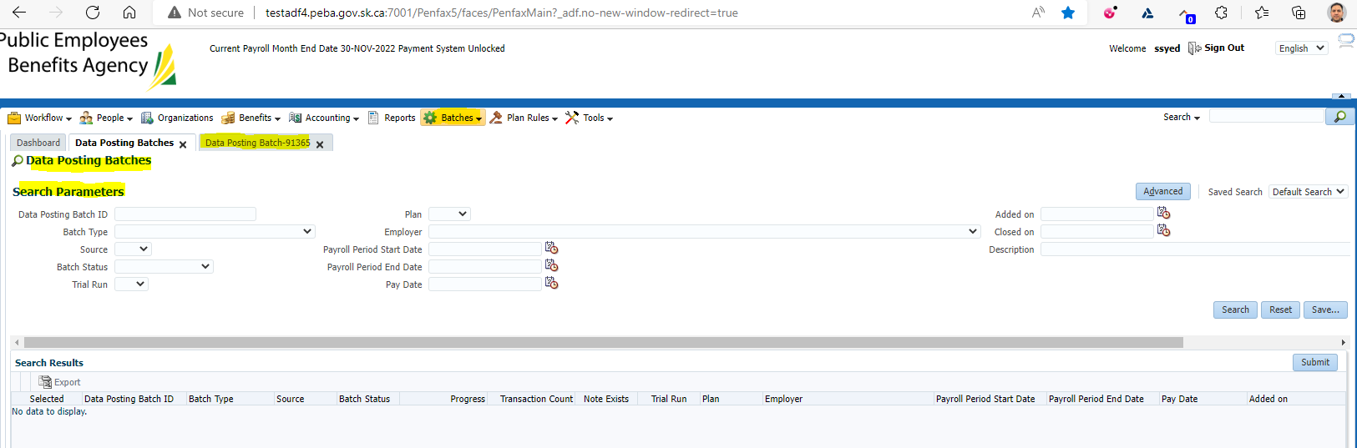

Click on Search under Search Parameters

Verify if all the Header screen details are displayed

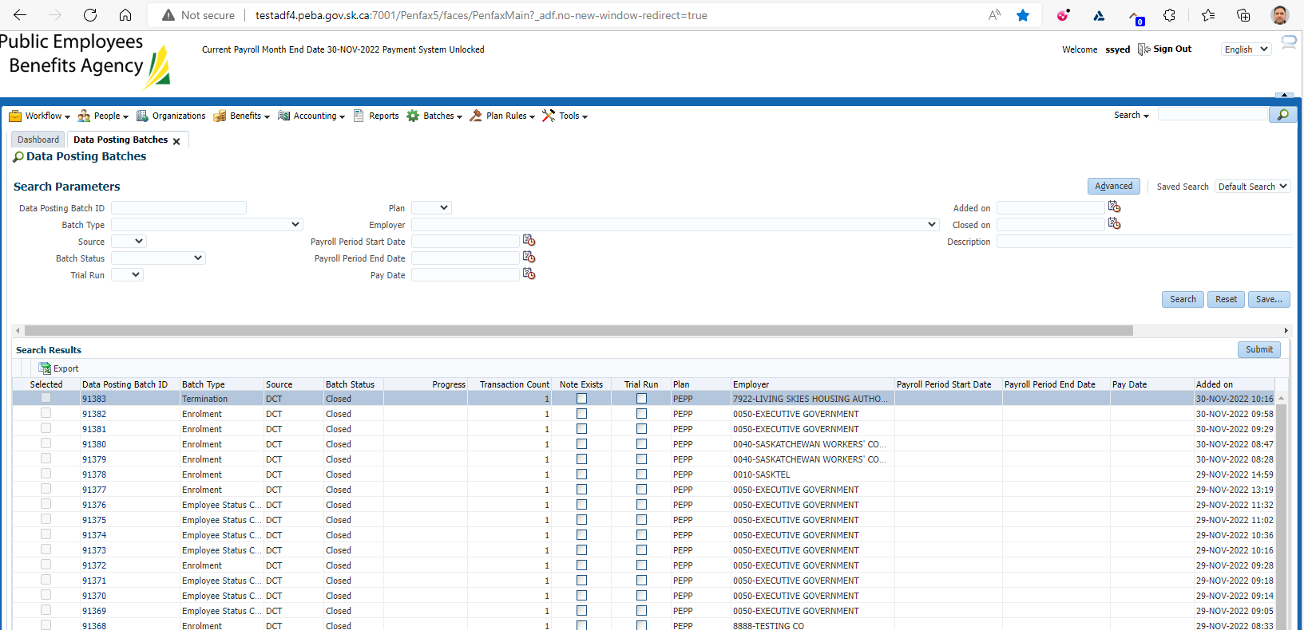

Under Search Parameters

Select Batch Status as ‘Open’

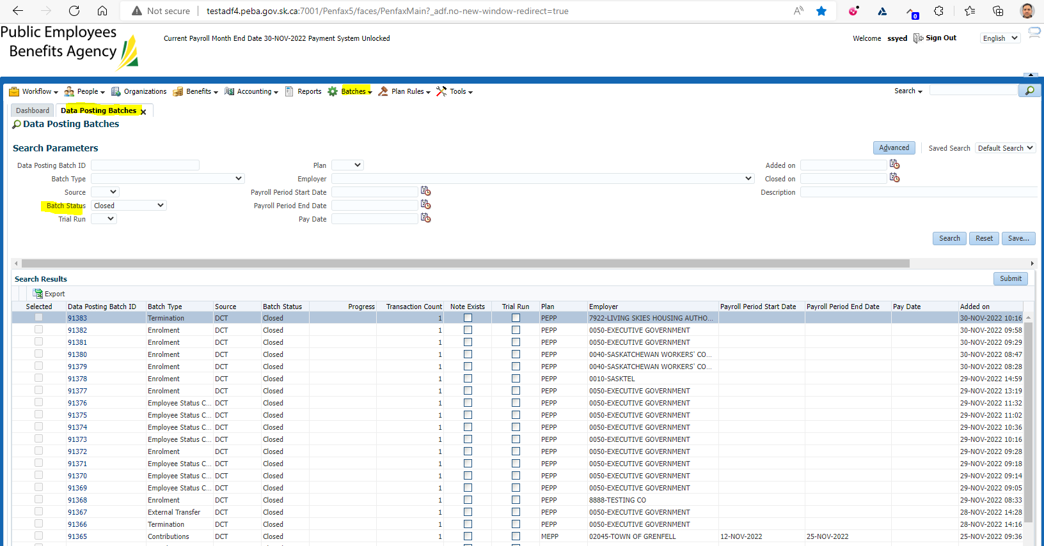

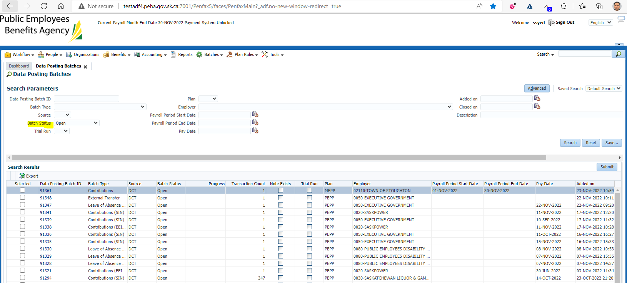

Verify if the Data Posting Batch is displayed under Pending tab details

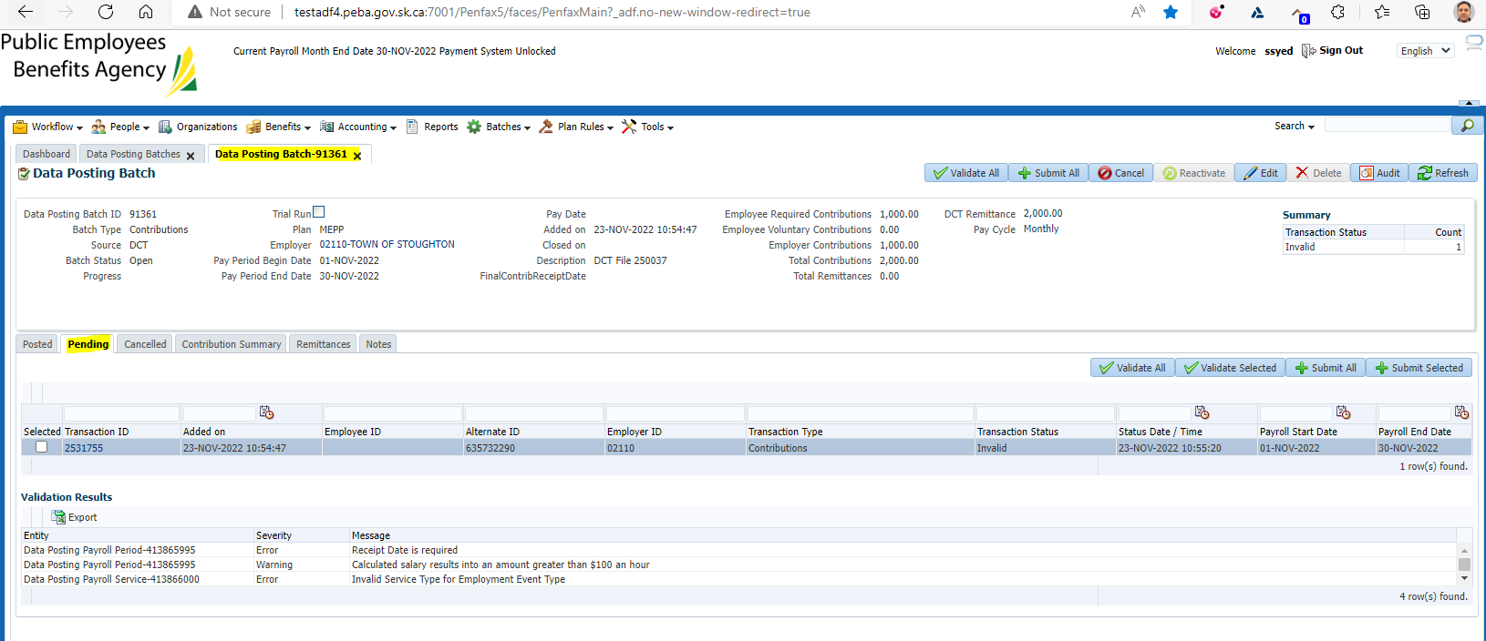

Result: Pass